**Power BI Dashboard**

**HR Analytics**



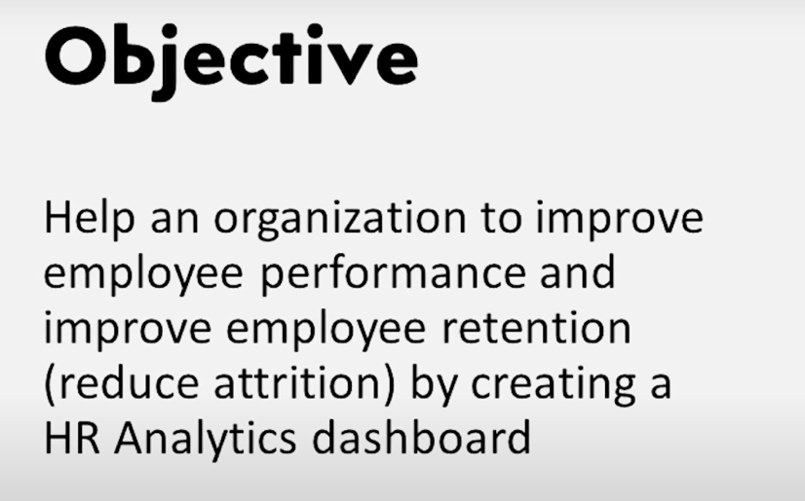

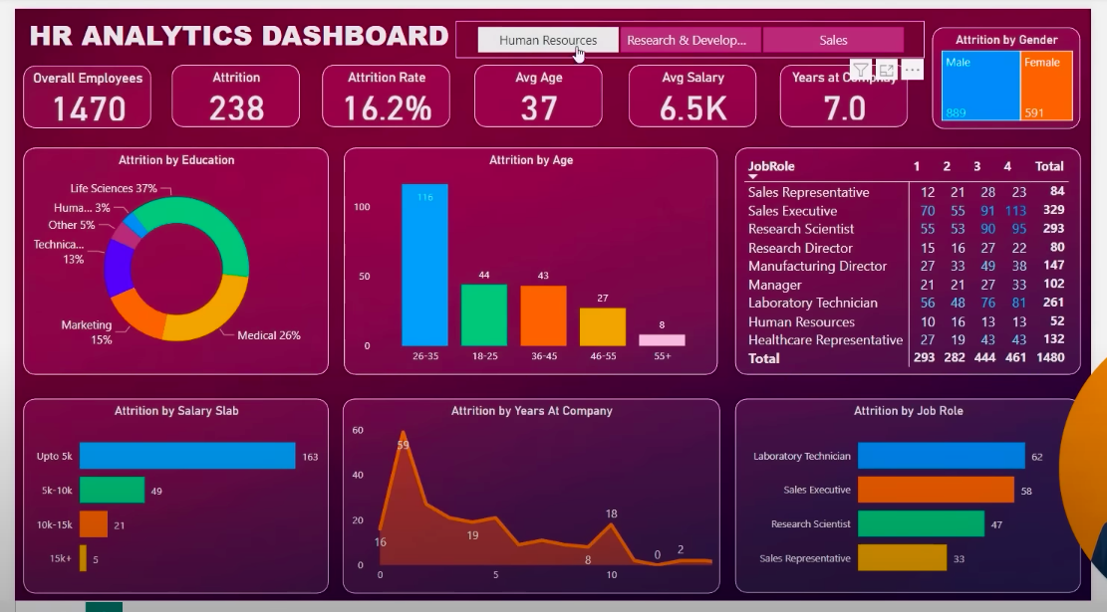

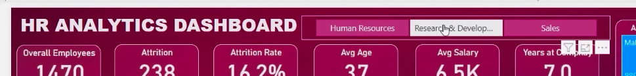

Dataset Review:

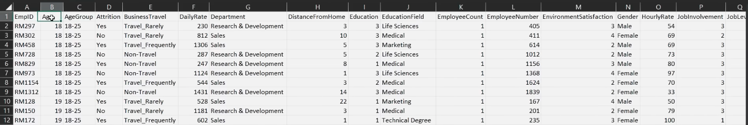

Total 38 columns



Now, we have to decide which columns we need to show in our dashboard.

The aspects are:

* Scope of the project: what are the reasons that employees leaving our company?
* KPIs supporting story: create a Pivot Table to check

Let’s create a Pivot Table in Excel

**Insert** --> **Pivot** **Table** --> From Table/ Range

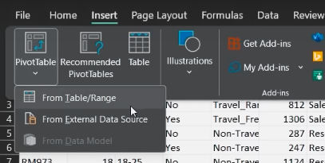

Click **OK**

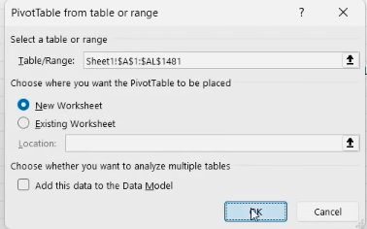

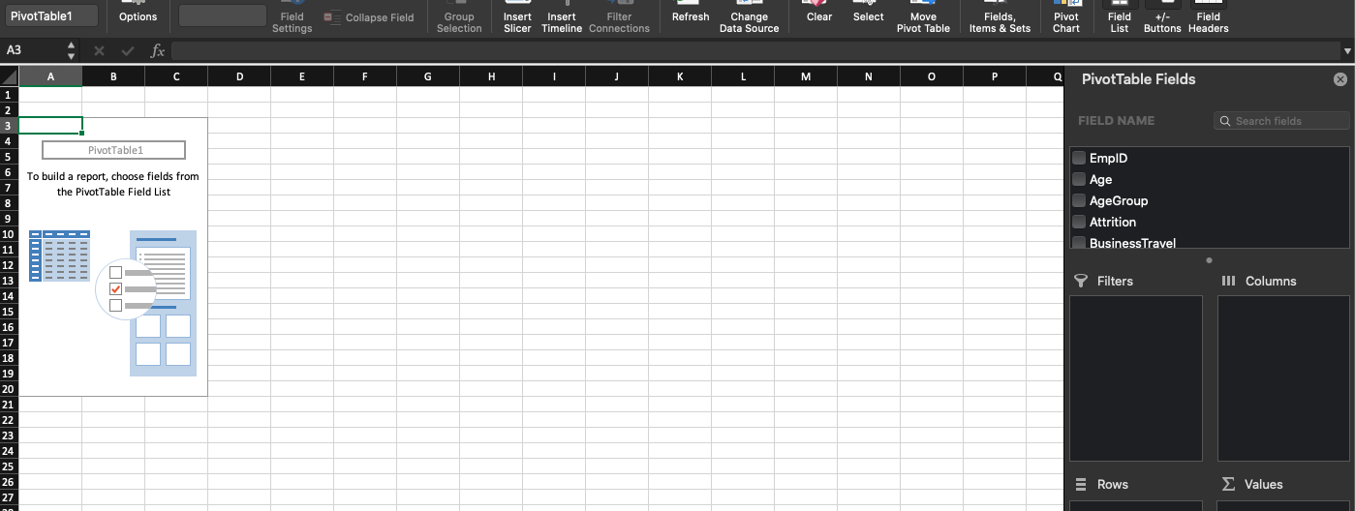

Now, check for all the useful combinations of attributes/ columns.

1. **Age, count (EmpId), Attrition**

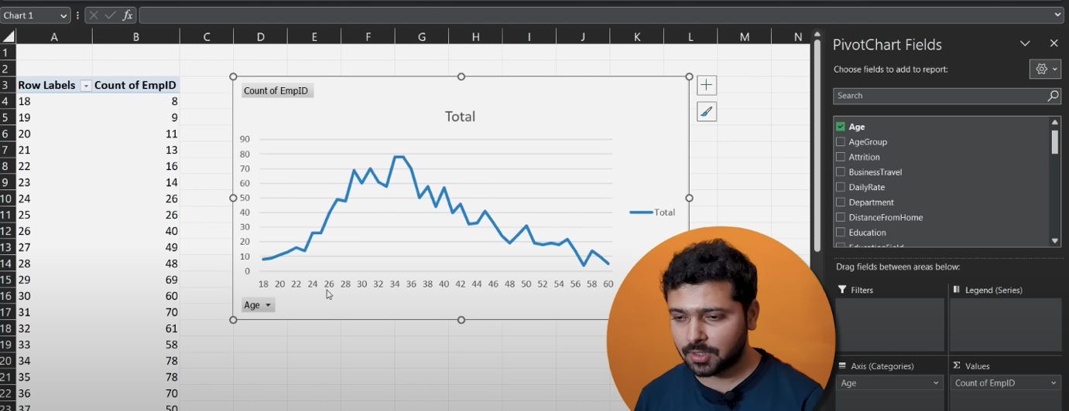

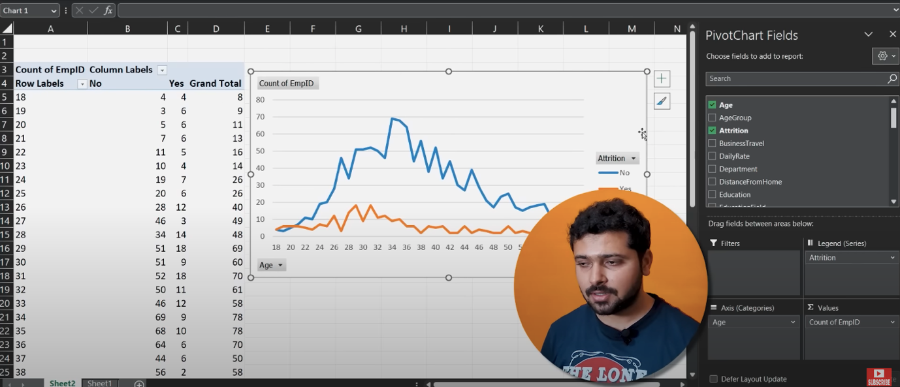

The graph’s attributes seems to be important, so we will keep them.

1. **EmpId, Attrition, Business Travel**

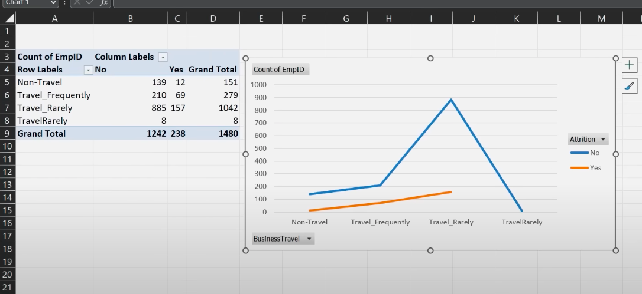

**Business Travel** is not useful attribute.

1. We will keep **Research & Development**

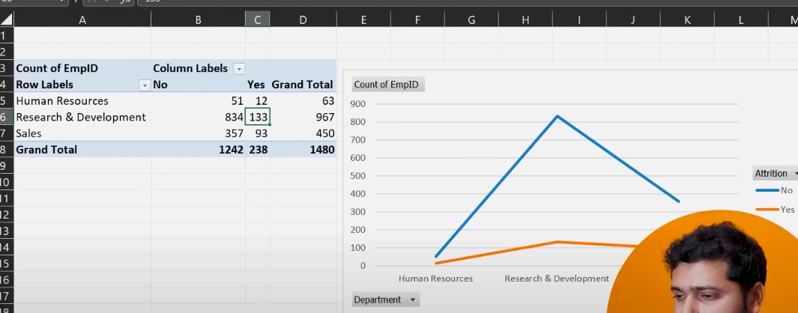

1. **Education Field** is also important

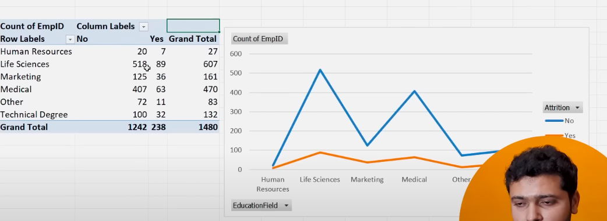

1. **Distance from Home** is useless

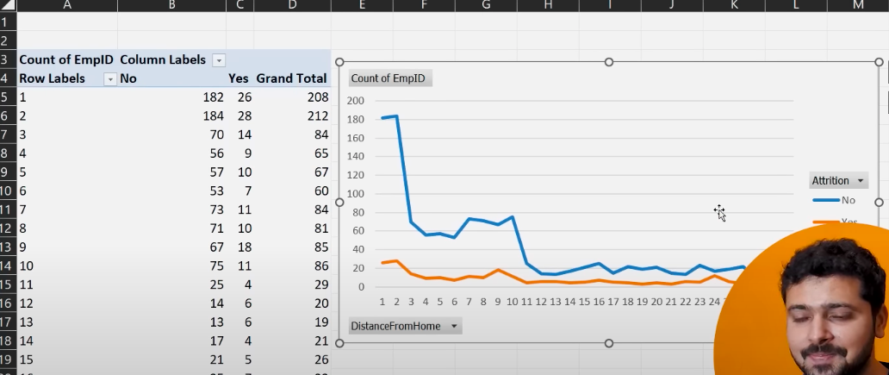



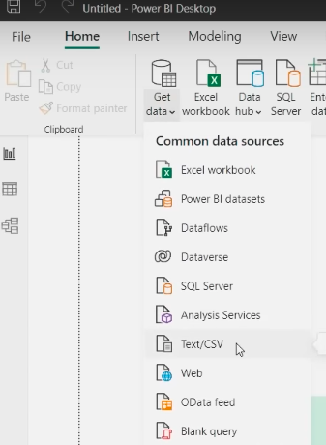

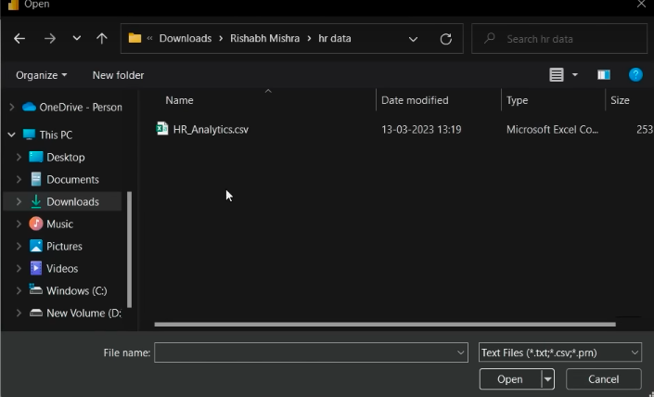

Click **Transform Data**

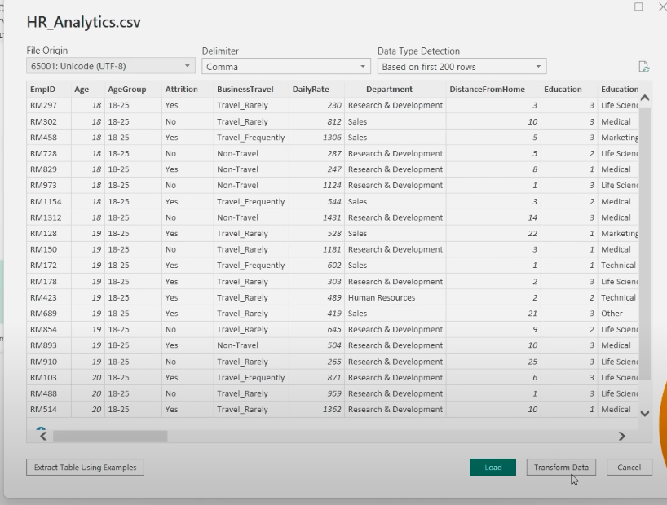

**Challenge 1**: How to remove **NULL** & **duplicate** **values** from dataset.

* Check for missing values in a column by hovering over it

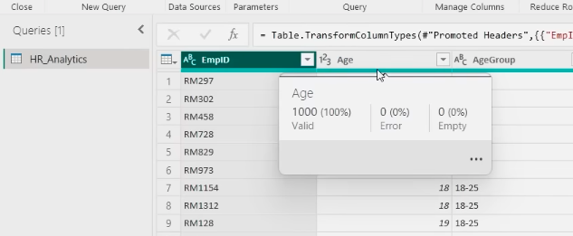

Go to **View** --> **Column Quality**

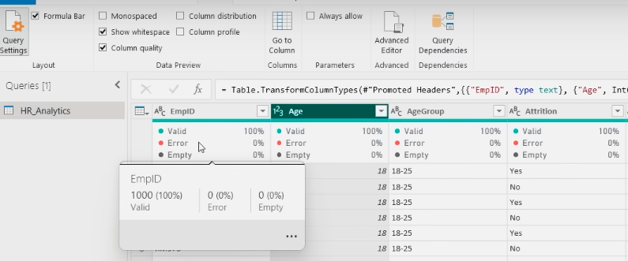

So, if there would be any NULL values it will show on the top.

While checking **YearsWithCurrManager**,we can see 4% NULL values

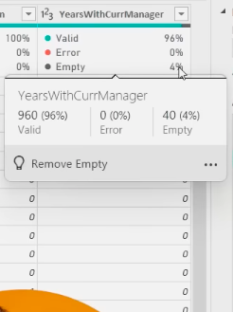

* To remove these NULL values

**Sort Ascending** --> check the last row number of NULL values (57)

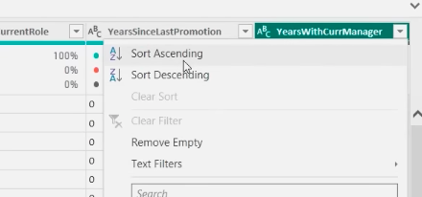

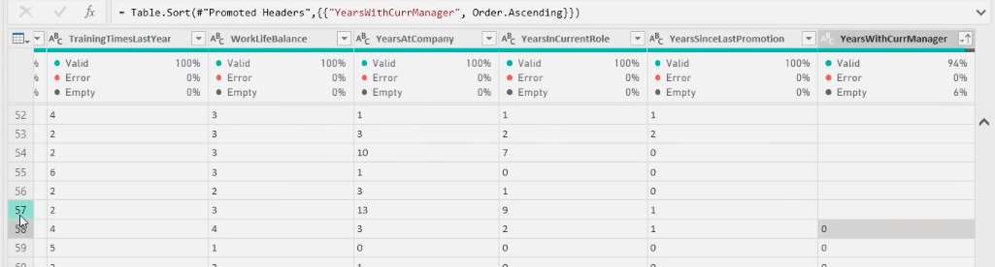

Now, **Home** --> **Remove** **Rows** --> **Remove Top Rows**--> put 57

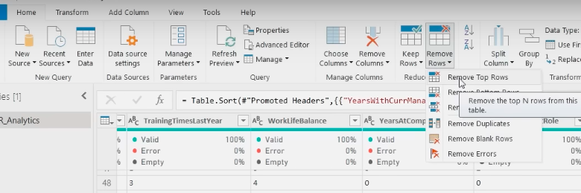

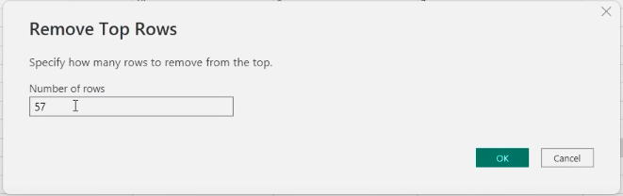

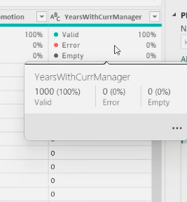

So, now we have no NULL values

* To remove **Duplicates**

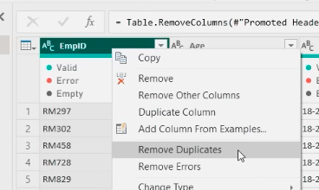

That will remove the duplicates in only one column **EmpID**

But, if an employee working in a company for 2-3 years then his/her EmpID will show up in different yearly data. So, we can’t remove the duplicate **EmpID** rows.

* To check for Duplicate values

As the EmpID is the primary key, so we won’t have duplicate values in that.

Go to **Home** --> **Group By**

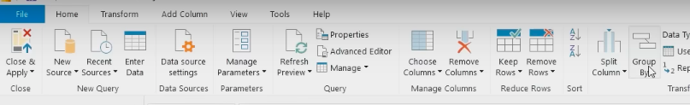

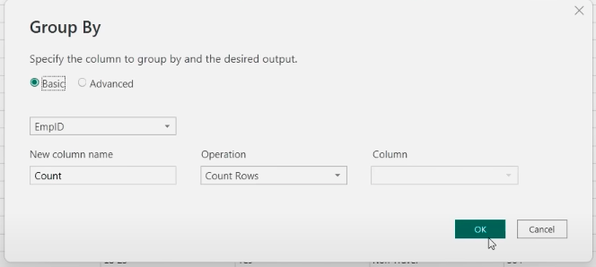

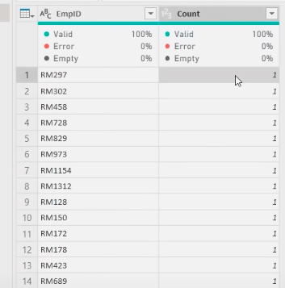

We have to look for those EmpID values which got count 2

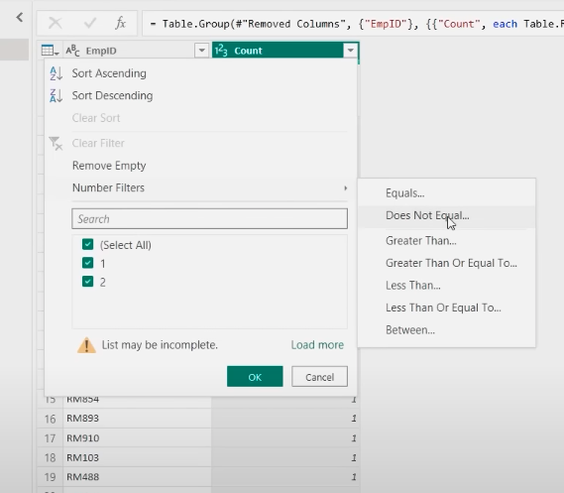

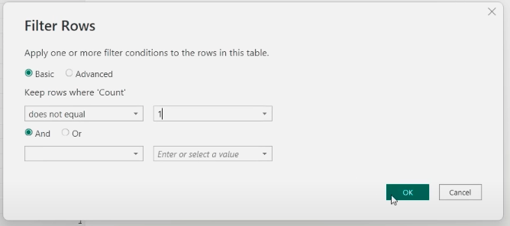

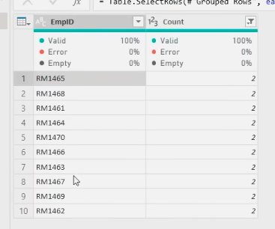

Now, we can see all the duplicate values in EmpID

To remove all the duplicate values in EmpID do the following: **click on EmpID** + **keep Shift key pressed** + **click Last column**

As all the columns are selected mow.

Now, click **EmpID** --> **Remove Duplicates**

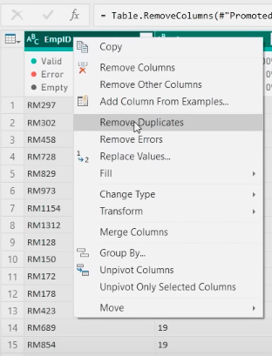

* **Spelling Error/ Find & Replace**

Go to every single column and check

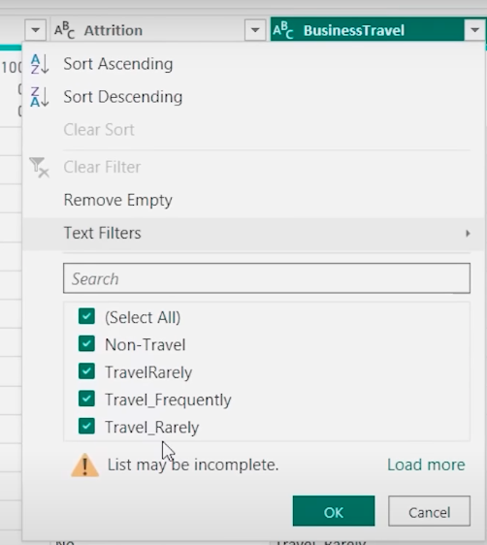

Now, we have to do **find & replace**

Simply click **on the value** & click **Replace Values**

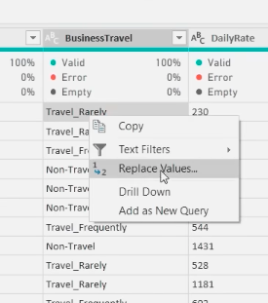

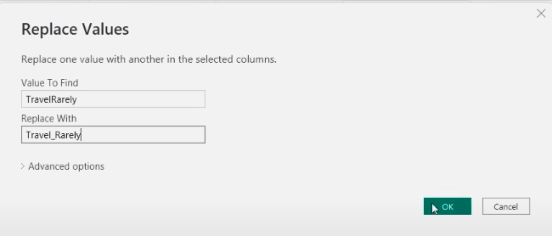

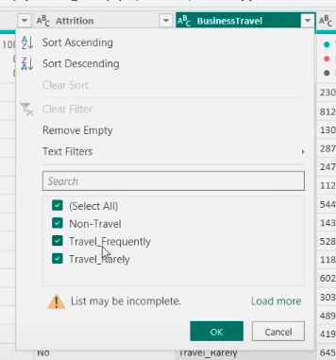

Hence, we replaced the error values.

* Put the correct **Data** **Type** for every column

First, select all the columns. Then, **Transform** --> **Detect Data Type**

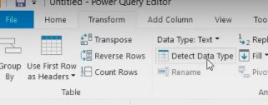

Now, all the Data Type are sorted.

At the end of Data Cleaning, click **CLOSE & APPLY**



* To put a background image:

Click anywhere in the **Canvas**, go to **Format** -- > **Canvas Background** --> **Browse**

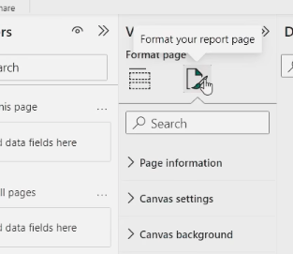

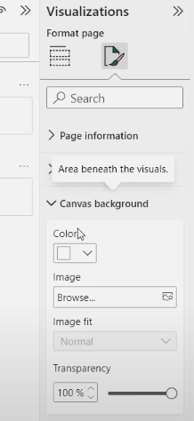



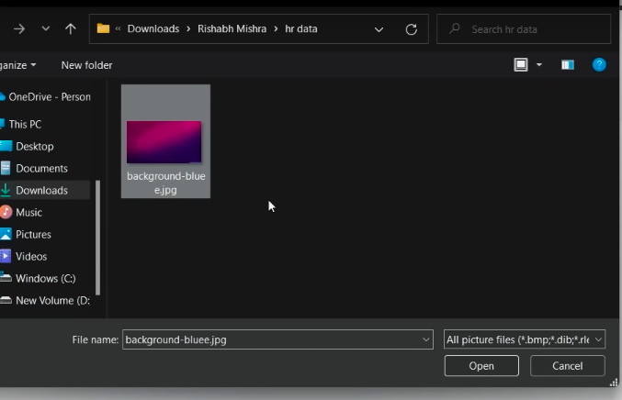

* Converting the Attrition values from YES/ NO to 1/0

Go to **Transform data** --> **Add column** --> **Conditional column**

